**Assignment – 4**

**Docker and Kubernetes**

|  |  |
| --- | --- |
| Assignment Date | 02 November 2022 |
| Team ID | PNT2022TMID02912 |
| Project Name | Nutrition Assistant Application |
| Maximum Marks | 2 Marks |

**Question-1:**

Pull an Image from docker hub and run it in docker playground.

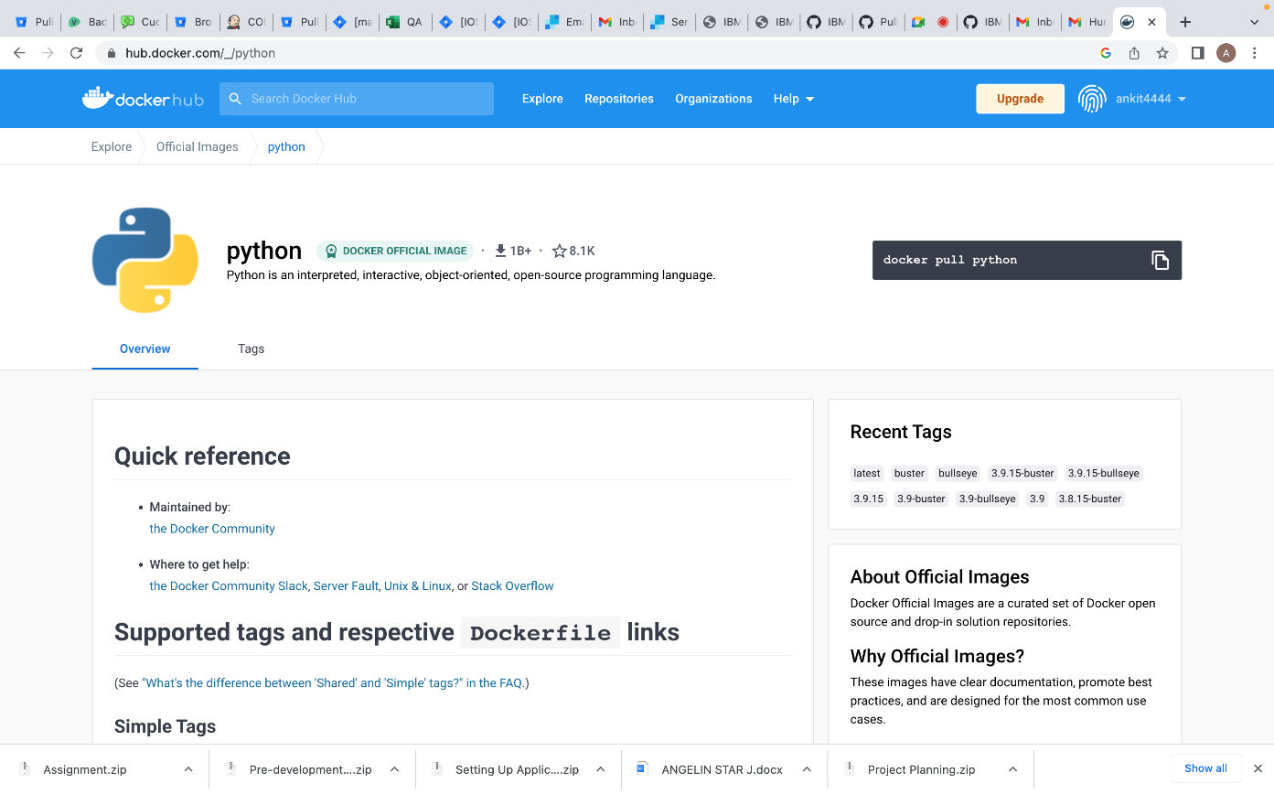

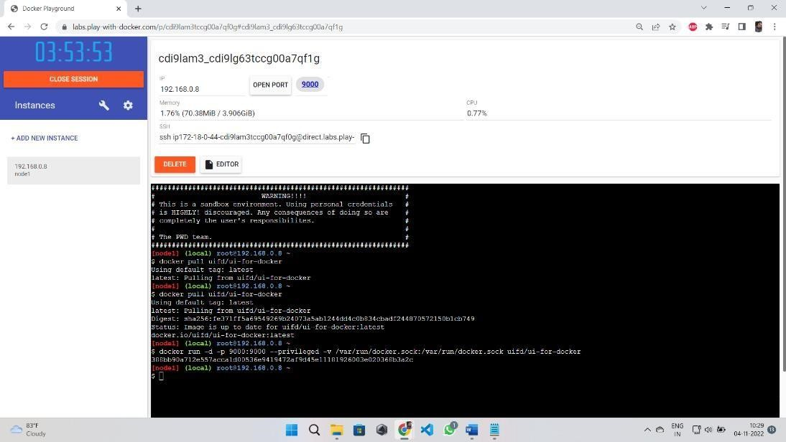

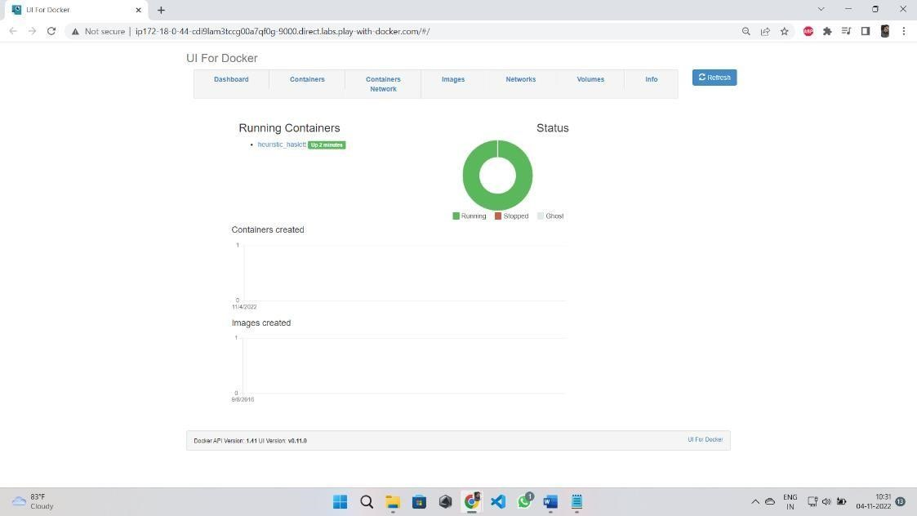

**Question-2:**

Create a docker file for the job portal application and deploy it in Docker desktop application.

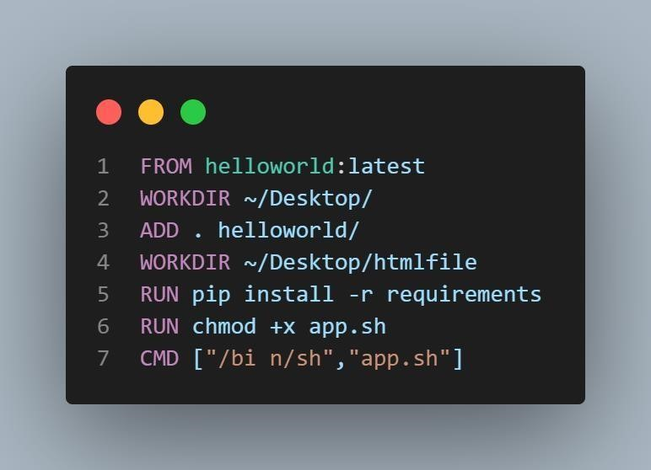

**Question-3:**

Create a IBM container registry and deploy helloworld app or job portal app.

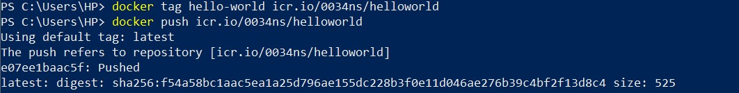

**Question-4:**

Create a Kubernetes cluster in IBM cloud and deploy helloworld image or job portal image and also expose the same app to run in nodeport.

